  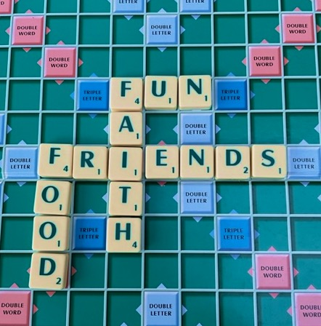
  Tuesday 25th November 2025
  19:15 to 21:00
  Venue:
  Kemble Lodge, Kemble, Cirencester,
  GL7 6AD.
  Interested? Want to know more?
  Contact:
  Toto Walls 07989 301120
  Aileen Shaw 07807 199602
  Julie Allen 07704 892029
  DONATIONS WELCOME
  
  Thameshead
  Ladies
  Connection
  #TLC
  Come & Join us
  ALL WELCOME
  MULLED wine & MINCE PIES
  Kat
  FLOWERS AND FAITH
  BETH BRUCE-GARDNER
  Will be sharing her passion for SUSTAINABLE FLORISTRY.
  Including a CHRISTMAS TABLE DECORATION DEMONSTRATION
  RSVP to Antonia, Aileen or Julie
  www.honeymoonfern.com..org.uk

