FLORA | 2023 | 2024 | 2025 | 2026
Autumn crocus |  |  | Sept
Barberry
Bluebell |  |  | April
Bramble
Bristly oxtongue |  |  | June
Cherry |  |  | April
Cleavers/Stickywilly |  |  | April
Cocksfoot (grass) |  |  | June/July
Common bent grass
Copper beech
Cornus Kousa
Cotoneaster
Cow parsley |  |  | April
Cowslip
Creeping buttercup
Cuckoo pint
Daffodil |  |  | March
Daisy |  |  | April
Dandelion
Dock
Dog violet |  |  | April
Dutch clover |  |  | June
Elder
False oat grass
Field bindweed |  |  | June
Forget-me-not |  |  | April
Fox glove |  |  | June
Fringe cup
Grape hyacinth |  |  | April
Ground ivy
Hart’s tongue fern
Hedge woundwort
Herb robert
Honeysuckle
Ivy
Knapweed |  |  | June
Lords and ladies
Meadow buttercup |  |  | June
Meadow foxtail (grass) |  |  | June/July
Moss
Musk mallow
Navelwort / wall pennywort
Nettle
Nipplewort
Oxeye daisy |  |  | June
Pignut (Conopodium majus)
Hoary Plantain |  |  | June
Poppy |  |  | June
Primrose |  |  | March
Ragged robin |  |  | June
Common Ragwort |  |  | July
Red campion
Rough/lesser hawkbit |  |  | June
Rowan
Rye grass
Selfheal (prunella vulgaris) |  |  | June
Snowdrop |  |  | February
Sow thistle
Speedwell |  |  | June
Thistle |  |  | June
Tufted hair (grass) |  |  | June/July
Whitebeam (Sorbus)
Woodavens
Wood sorrel
Yellow bedstraw |  |  | July
Yellow rattle
Yew
Yorkshire fog (grass) |  |  | June/July

FUNGA | 2023 | 2024 | 2025 | 2026
Common bonnet |  |  | September
Lichen – yellow
Lichen – white

FAUNA | 2032 | 2024 | 2025 | 2026
Bat (poo)
Black garden ant
Blackbird
Black lace weaver spider
Bluebottle
Blue tit
Bumble bee
Garden snail
Gatekeeper (butterfly)
Greenfinch
Hedgehog
Holly blue (butterfly)
Honey bee
House fly
Housemartin
Hover fly
Ladybird
Magpie
Meadow brown (butterfly)
Muntjac
Peacock butterfly
Red spider mite
Red wood ant
Robin
Small white (butterfly) |  |  | April
Song thrush
Swallows
Common Toad
Woodlouse spider |  |  | April
Woodpecker |  |  | Heard April
Wood pigeon
Wren
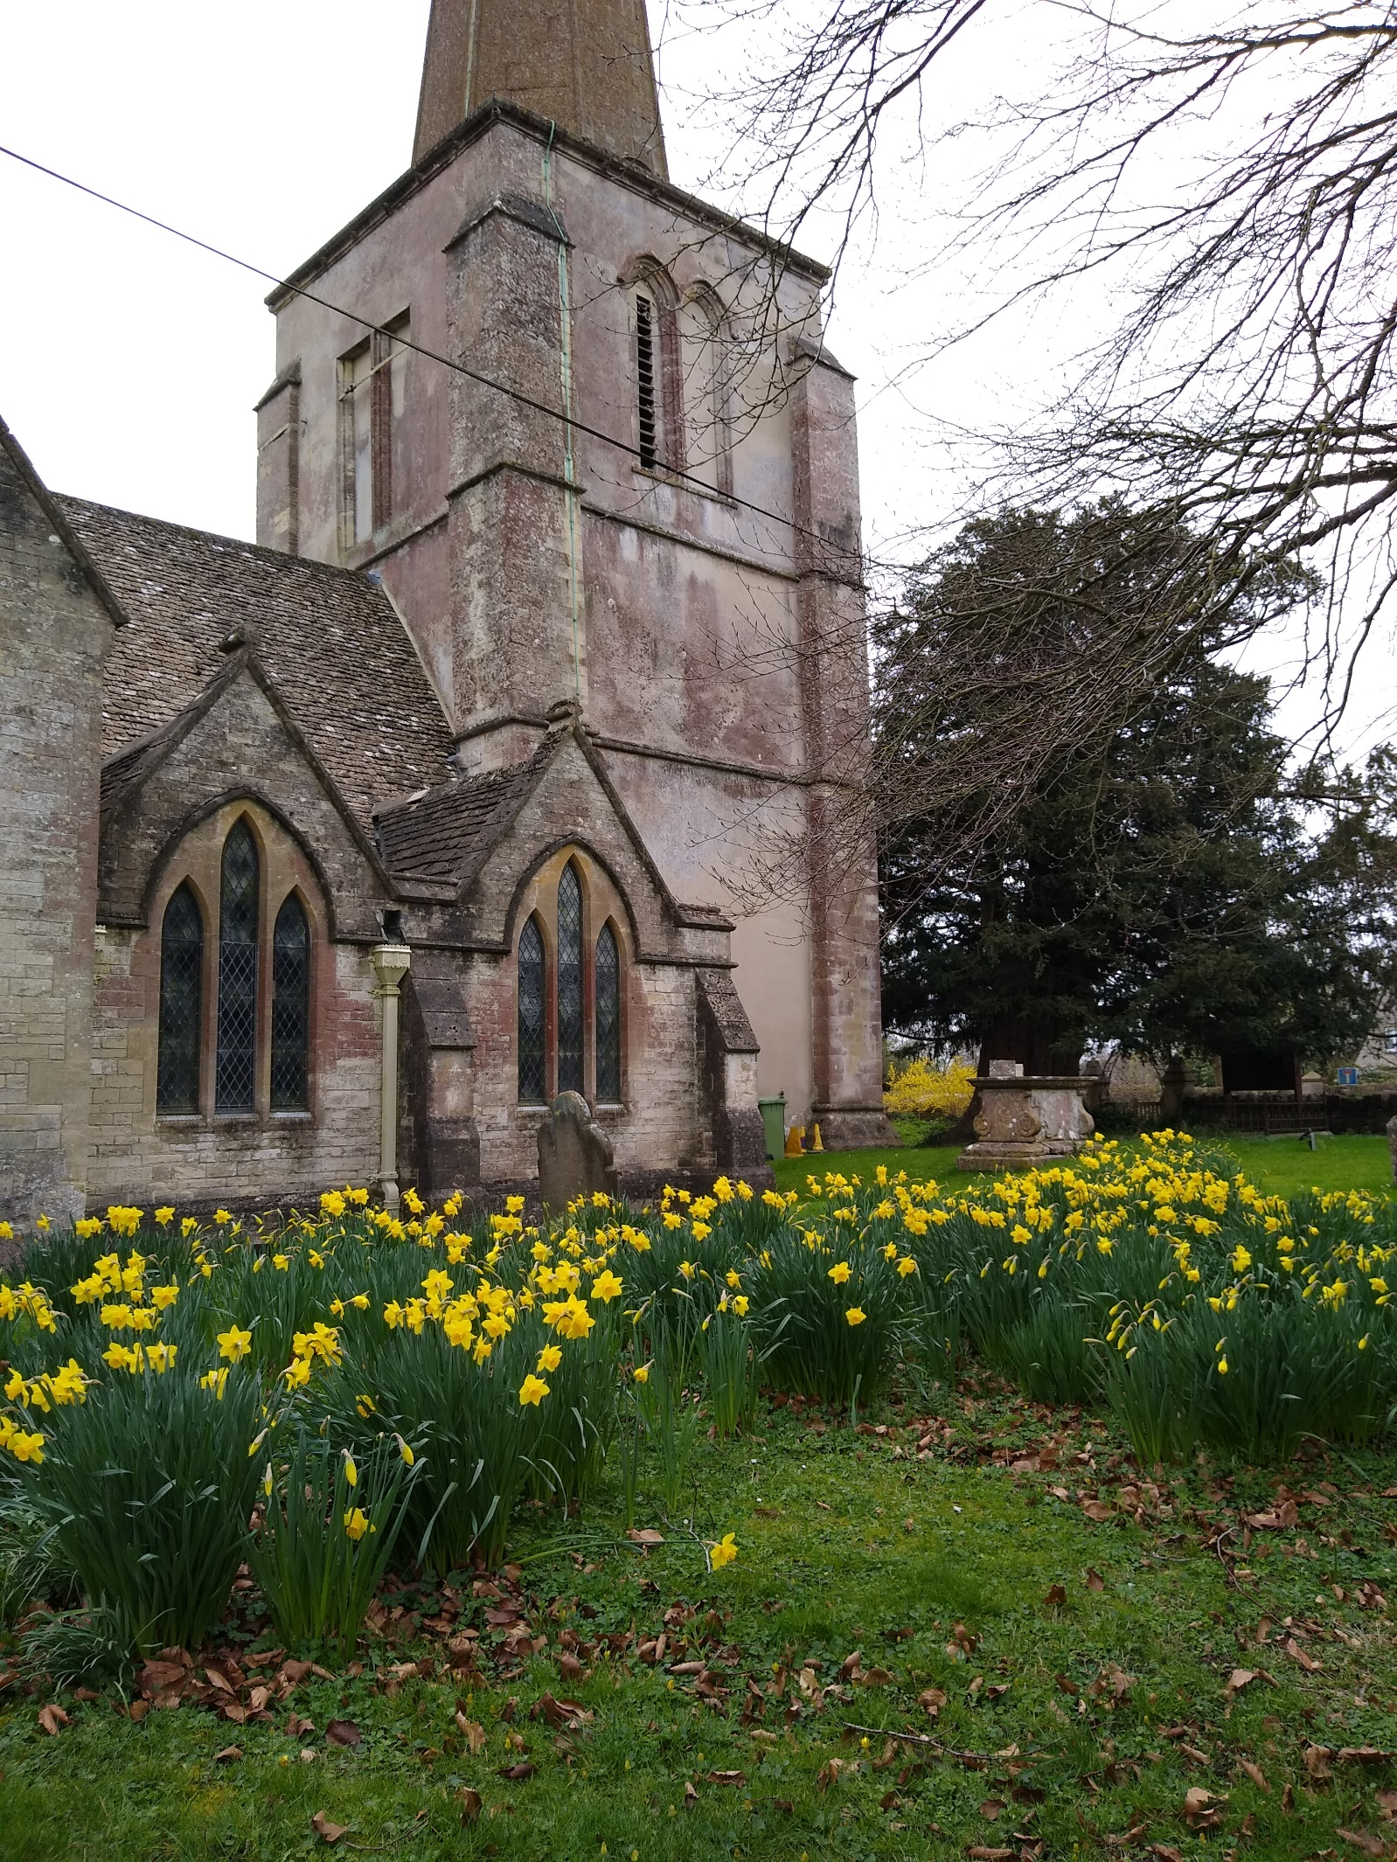
Kemble
Church
Nature
Survey

